**Response to the editor and reviewer**

We greatly appreciate the editor and the reviewer for the efforts and the valuable suggestions and hope that deficiencies pointed out in the original submission are overcome in the revised version. Our responses of the Referee’s Report are given below.

--------------------------------------------------

**General comments**

*1. p2, l7-8 It is not clear here if better estimates of divergence times have been obtained in the referenced papers or if this is simply an expectation*

**Author’s Response:**

Thanks for your comment.

To emphasize the proposed operator works in a relaxed clock model, we expect that relaxed models can help better explain genetic distances by allowing rates to vary throughout the tree, after reading the referred literatures. In the revised manuscript, we have rewritten the statements to avoid confusions.

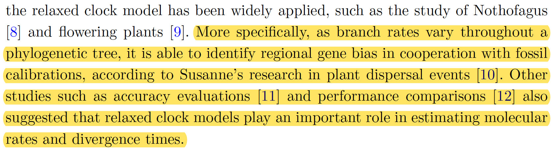

*2. p6, l44-45 On a dataset with sampling-through-time, the leaf node does not have to be the younger child. Does the operator still work in that case or is it a requirement that tO > tY ?*

**Author’s Response:**

Thank you for pointing out this special case.

After careful considerations and tests where trees have sampled ancestors, we confirmed that the operator should still work properly. So, we modified the requirements both in the code and revised manuscript. To be specific, in an asymmetric tree, the term “younger child” used in the original manuscript refers to the node having no child nodes, the term “old child” refers to the node having child nodes, and there is no need to satisfy tO > tY.

*3. There is a mismatch between Figures 12 and 13 which show results for S3 and Table 5 which contains the standard deviation of the clock, which according to Figure 11 is S1. Similarly p9, l26 it is unclear which of S1 or S3 was actually measured.*

**Author’s Response:**

We are sorry for making these mistakes.

In Figure 11, we used S1 to denote the standard deviation of the clock, and used S3 to denote the standard deviation of the LogNormal prior of S1, so that the framework of well-calibrated simulation study can be simple enough for readers to understand. In the revised manuscript, we have added more descriptions to explain the notations below the figure.

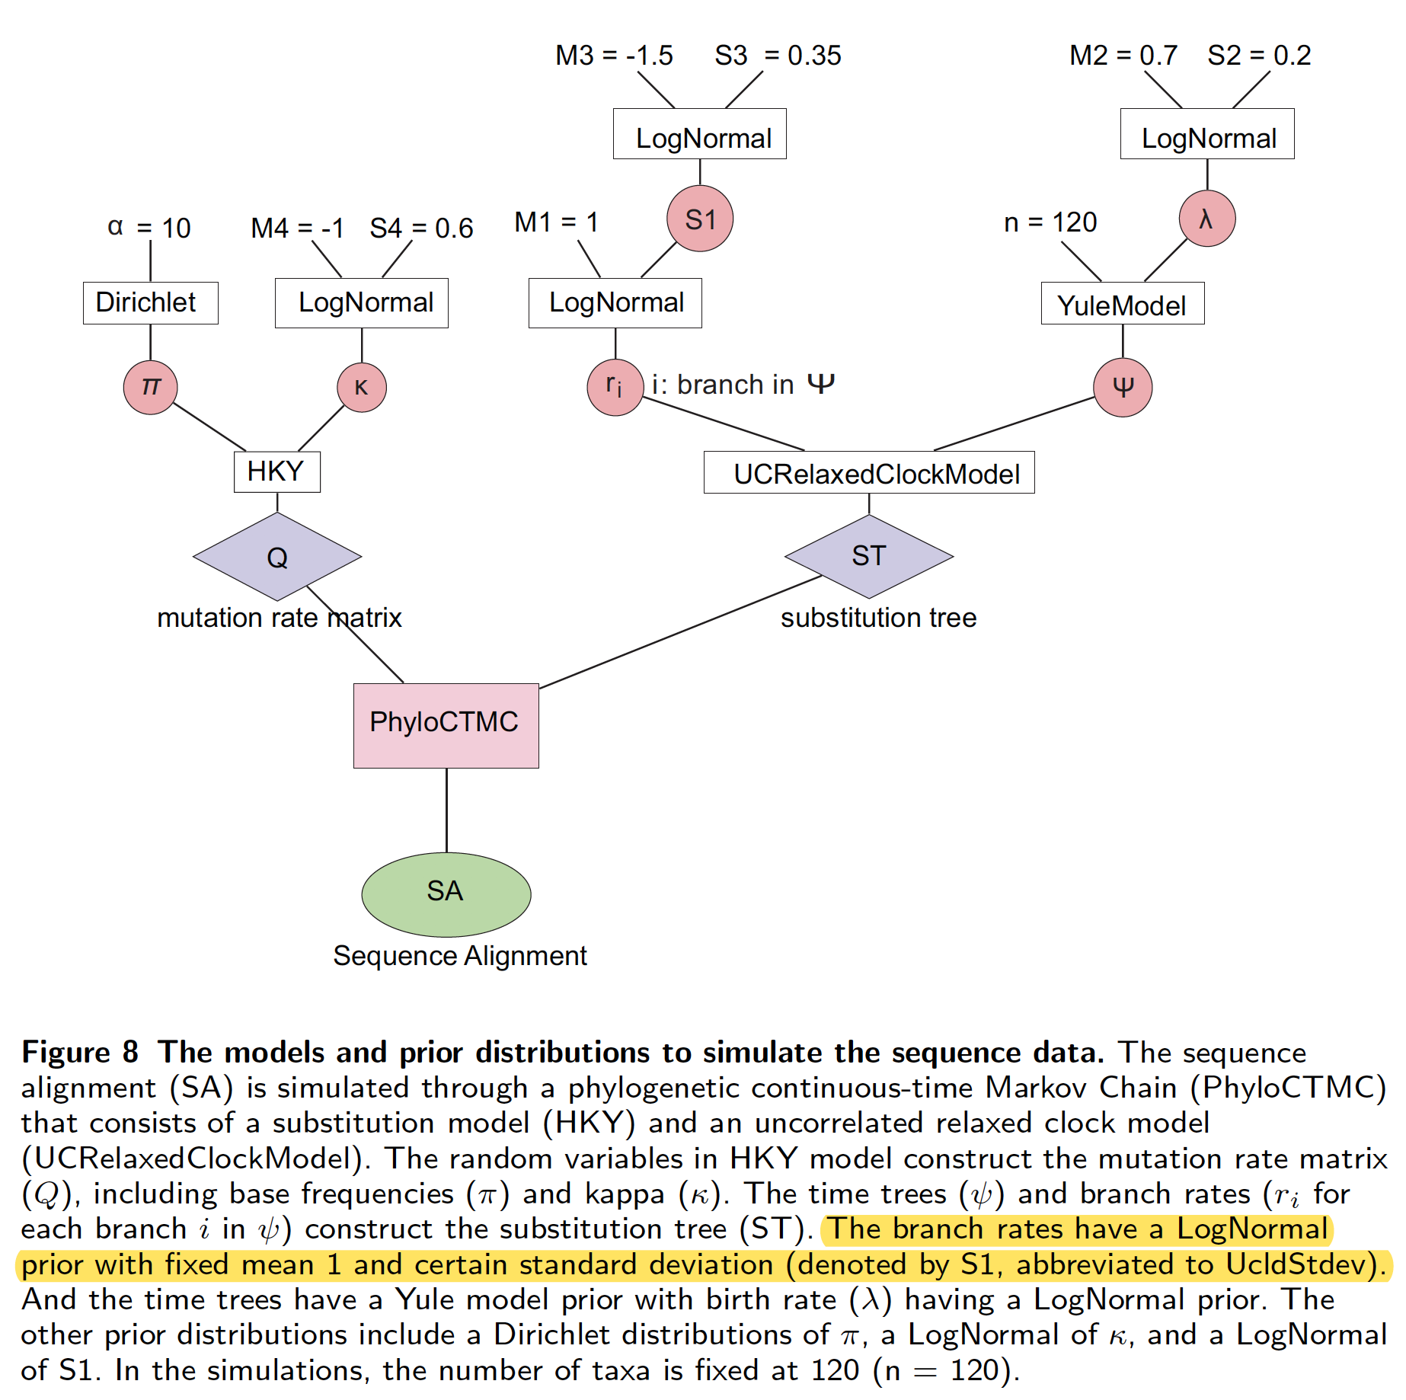

Additionally, in order to better identify what parameter is compared in Figure and Table, we used the more detailed terms such as “Kappa” and “BirthRate”.

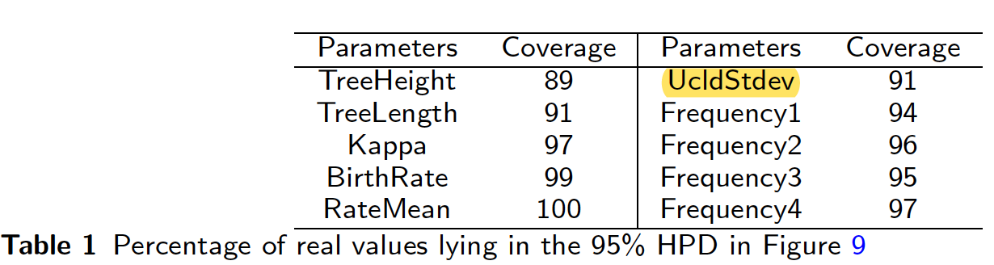

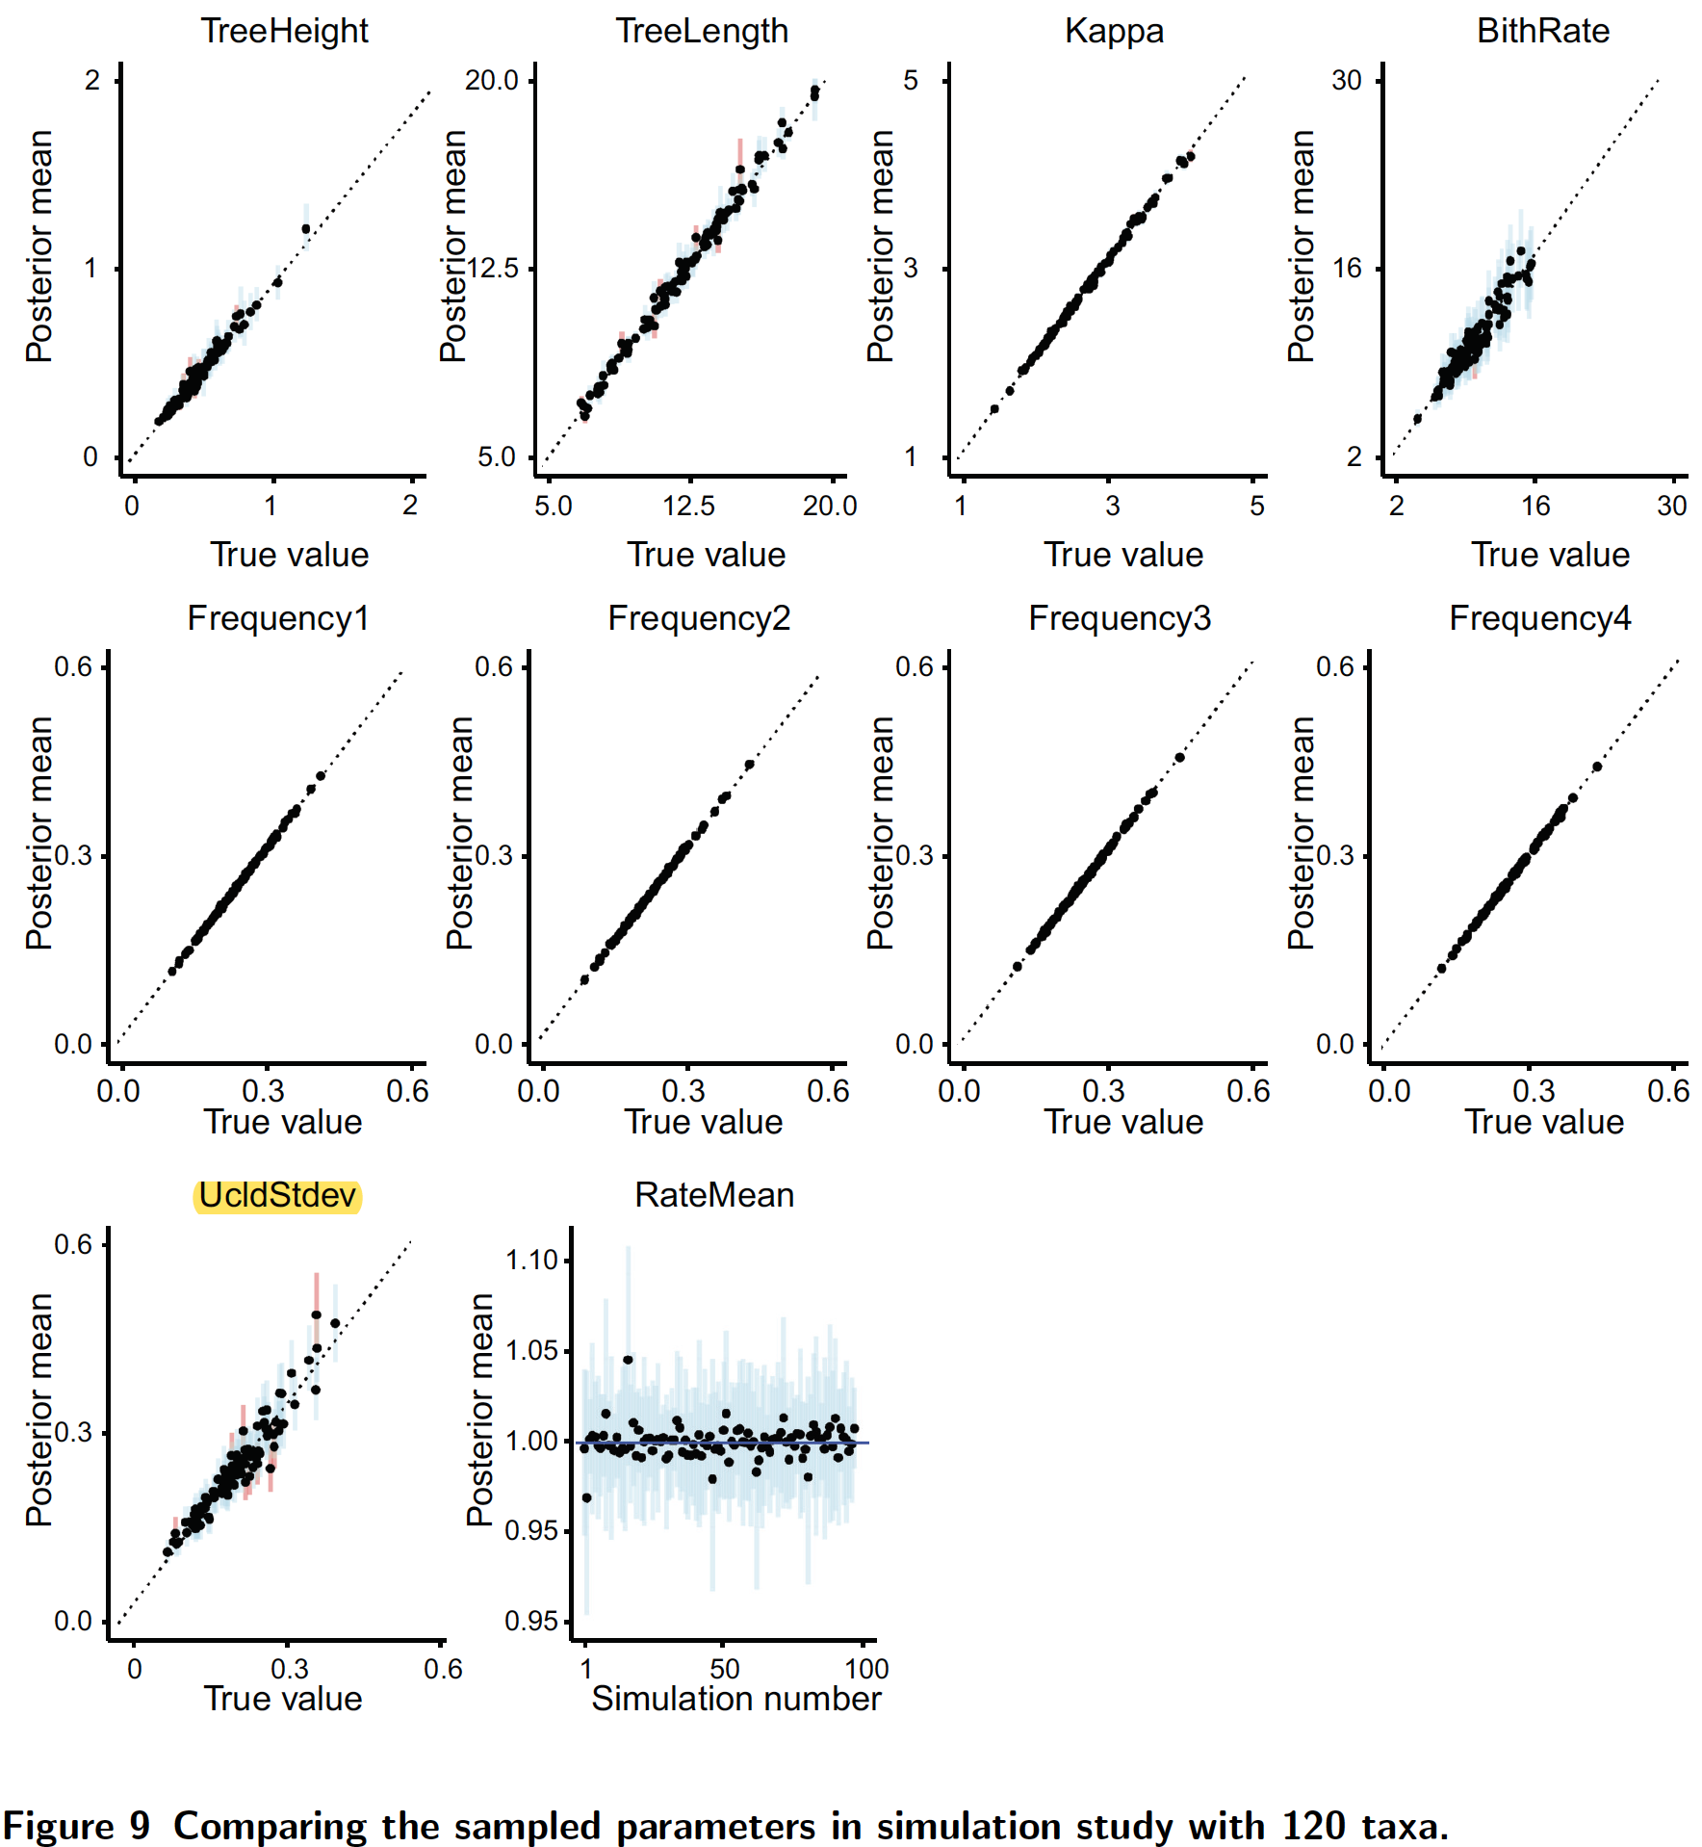

It is therefore S1 (UcldStdev) was acutely measured in p9, l26.

*4. p9 l33-34 I suggest adding some details on why configuration 1 was chosen as a comparison.*

**Author’s Response:**

Thank you for your professional suggestion.

In the revised manuscript, we have added more details to clarify the configurations in Section Performance comparison.

*5. p10, l16 I don't understand what "the sampled trees were filtered by the shared common ancestor of each taxa" means. Later l22 it appears that the authors discarded the trees which did not match the reference topology, but it's unclear if that is the same thing as the previously mentioned filtering or an entirely different step of the process.*

**Author’s Response:**

Thank you for your comment.

In this section, we ran a MCMC chain with length 200000000 using BEAST2 and got 2001 sampled trees throughout the whole chain. Then, we used the maximum clade credibility tree (Figure) to filter the 2001 sampled trees. Namely, we obtained the trees that have the same topology and clades as the maximum clade credibility tree. Hence, the trees that do not match the maximum clade credibility tree are discarded, in other words, the correlation analysis was conducted by using the branch rates and node times in the tree that match the maximum clade credibility tree.

To make it clear, we have rewritten the statement of the process to avoid multiple lines describing similar content.

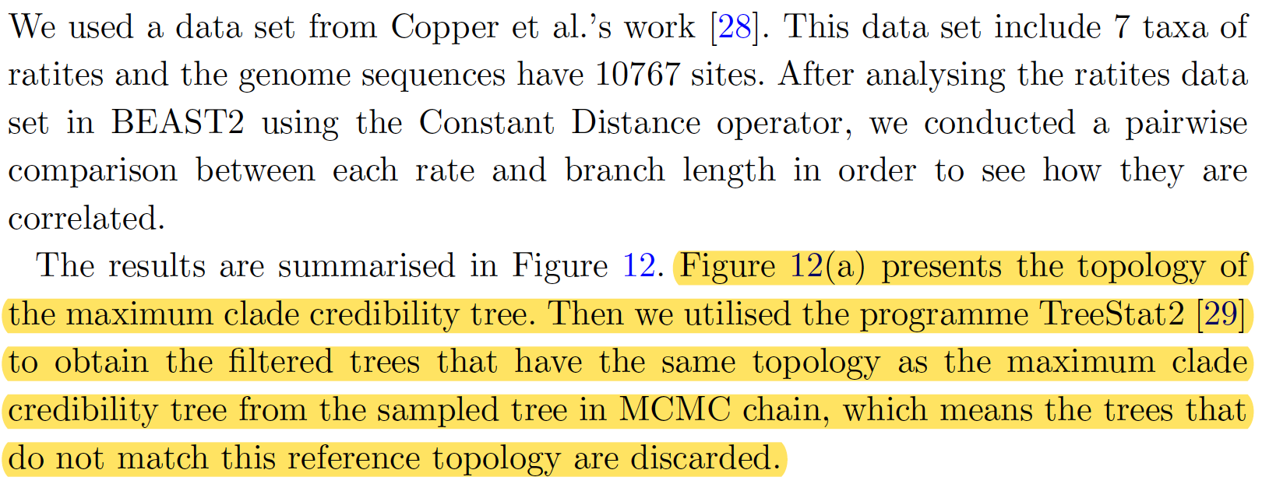

*6. p10, l37-42 Is it really unexpected that the results obtained using the new operators would be consistent with the correlations enforced by these new operators ? Overall it's unclear what the conclusions from this section are.*

**Author’s Response:**

Thank you for your comment and question.

*7. p11, l8-23 It is very unclear what was actually done in this section. For instance, were the assigned divergence times and rates fixed in the analysis? If so, how were they calculated, and if not, what are the values shown in figure 17? How were the summary trees obtained?*

**Author’s Response:**

Thank you for your question.

In this section, we aim at

*8. Figures 12 and 13 are identical.*

**Author’s Response:**

In the latest manuscript, Figure 12 that shows the well-calibrated simulation results of 20-taxa data set has been removed.

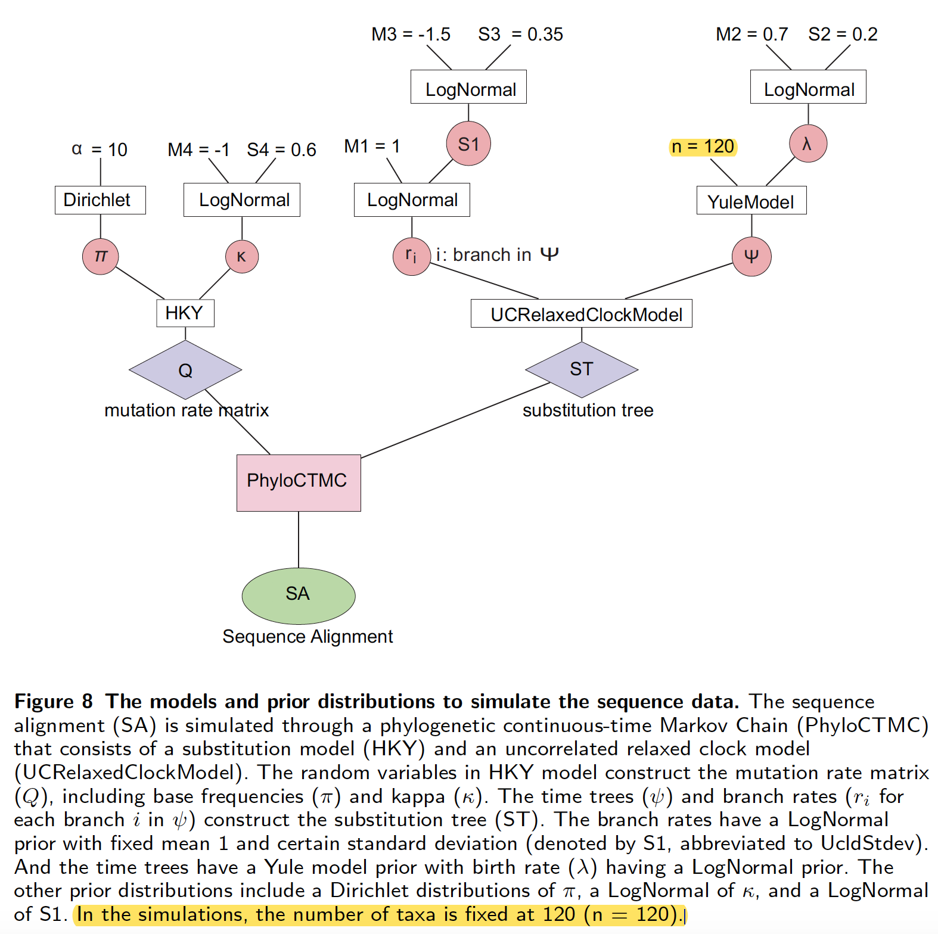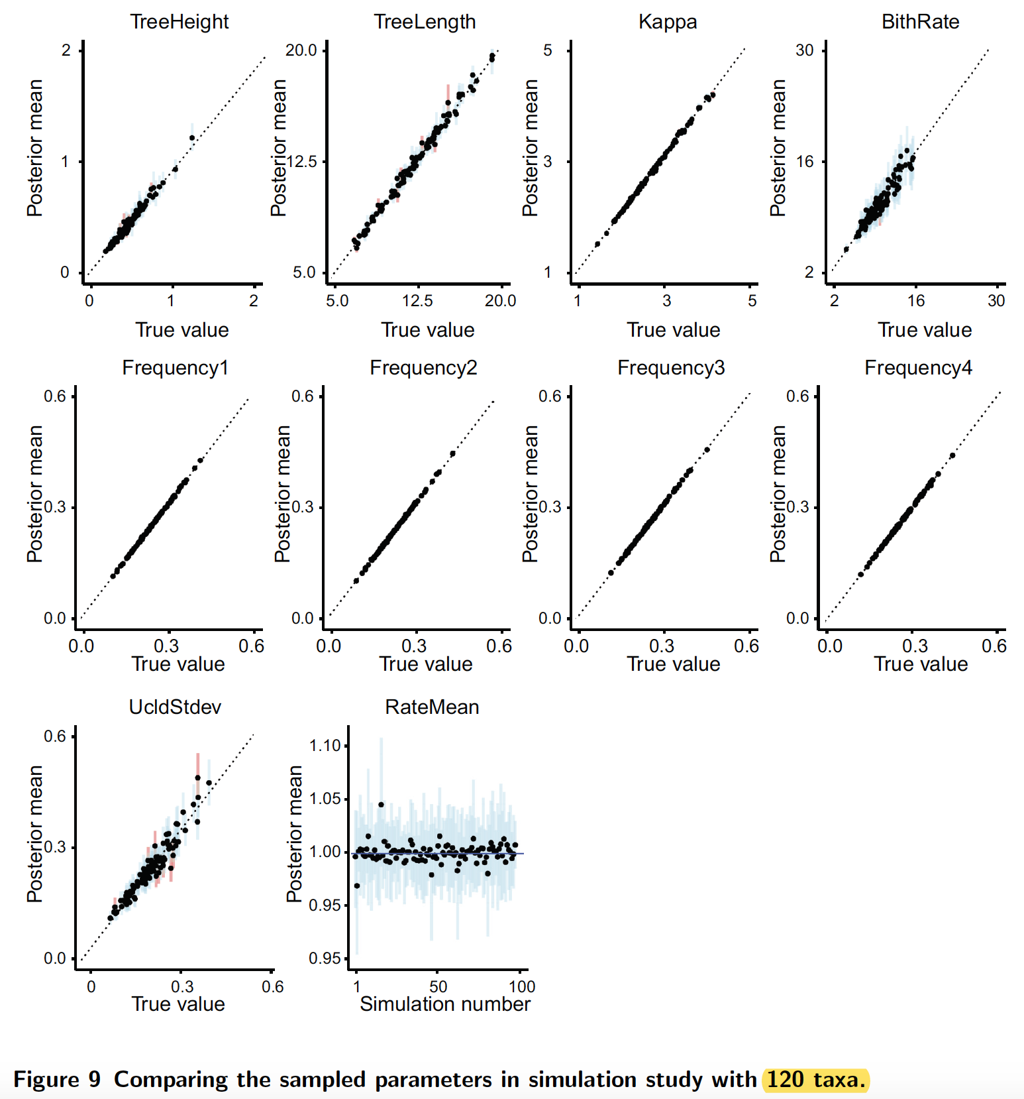

*9. Figure 16b I suggest adding a legend showing the range of plotted values.*

**Author’s Response:**

Thank you for your valuable advice.

In the revised manuscript, we have updated the figure plotting correlation ships.

*10. I would put a time axis on figure 17, as the credible intervals shown are not very meaningful without it.*

**Author’s Response:**

Thank you for your comment.

In the revised manuscript, we have put a time axis below each tree in Figure.

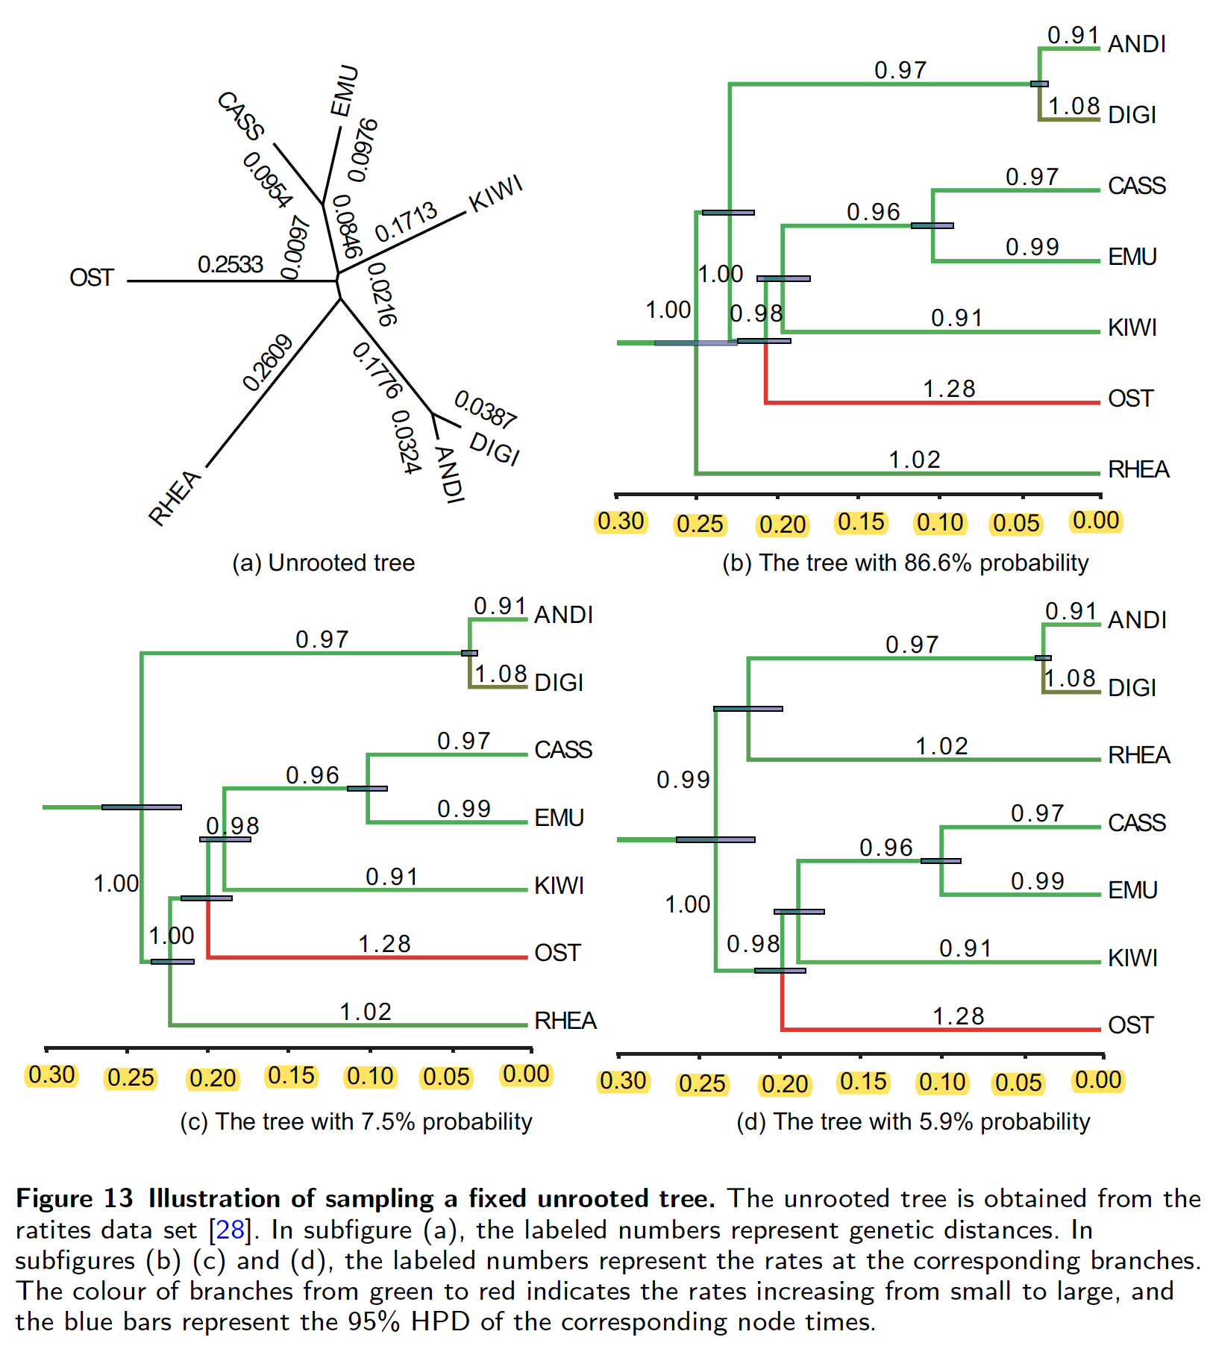

**Minor comments**

**Author’s Response:**

After carefully reviewing the original manuscript, the following mistakes that you pointed out have been corrected in the revised manuscript.

*1. p1, l30 It is noticed that -> Note that*

*2. p2, l39 Prelimiaries -> Preliminaries*

*3. p4, l37 max(tj, tk) -> max(tL, tR)*

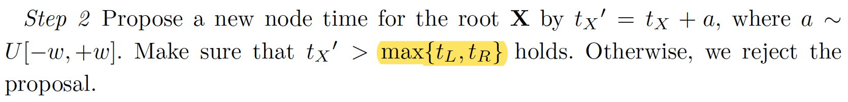

*4. p4, l53 the total genetic distance dL and dR -> the total genetic distance dL + dR*

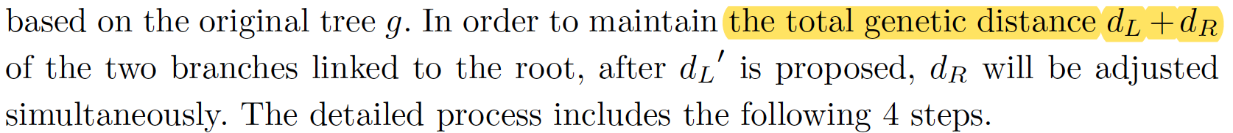

*5. p6, l54 what happens if tO' < min(tG1, tG2) ?*

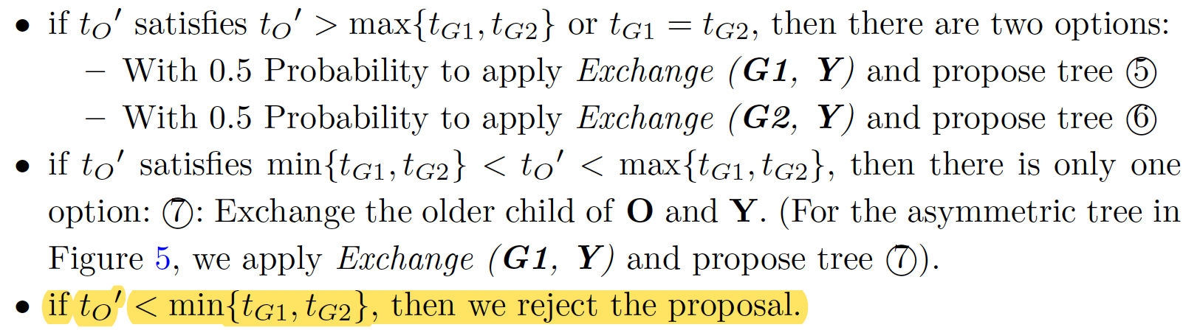

*6. p9, l26 MCMC simulation -> MCMC inference*



*7. p10, l48 becomes -> become*

*8. Figure 1 remove the box which only contains =*

*Figure 1 H3,R and H4,R should be H3,L and H4,L*

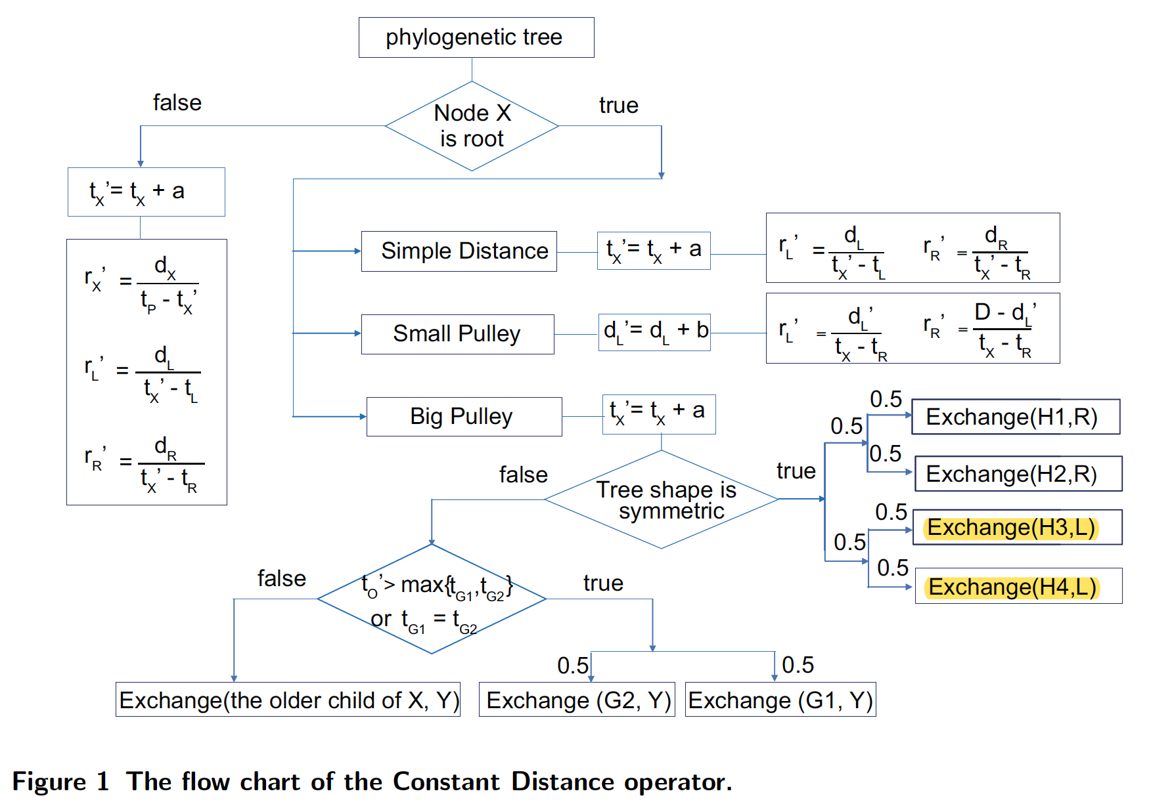

*10. Figure 11 substituion tree -> substitution tree*

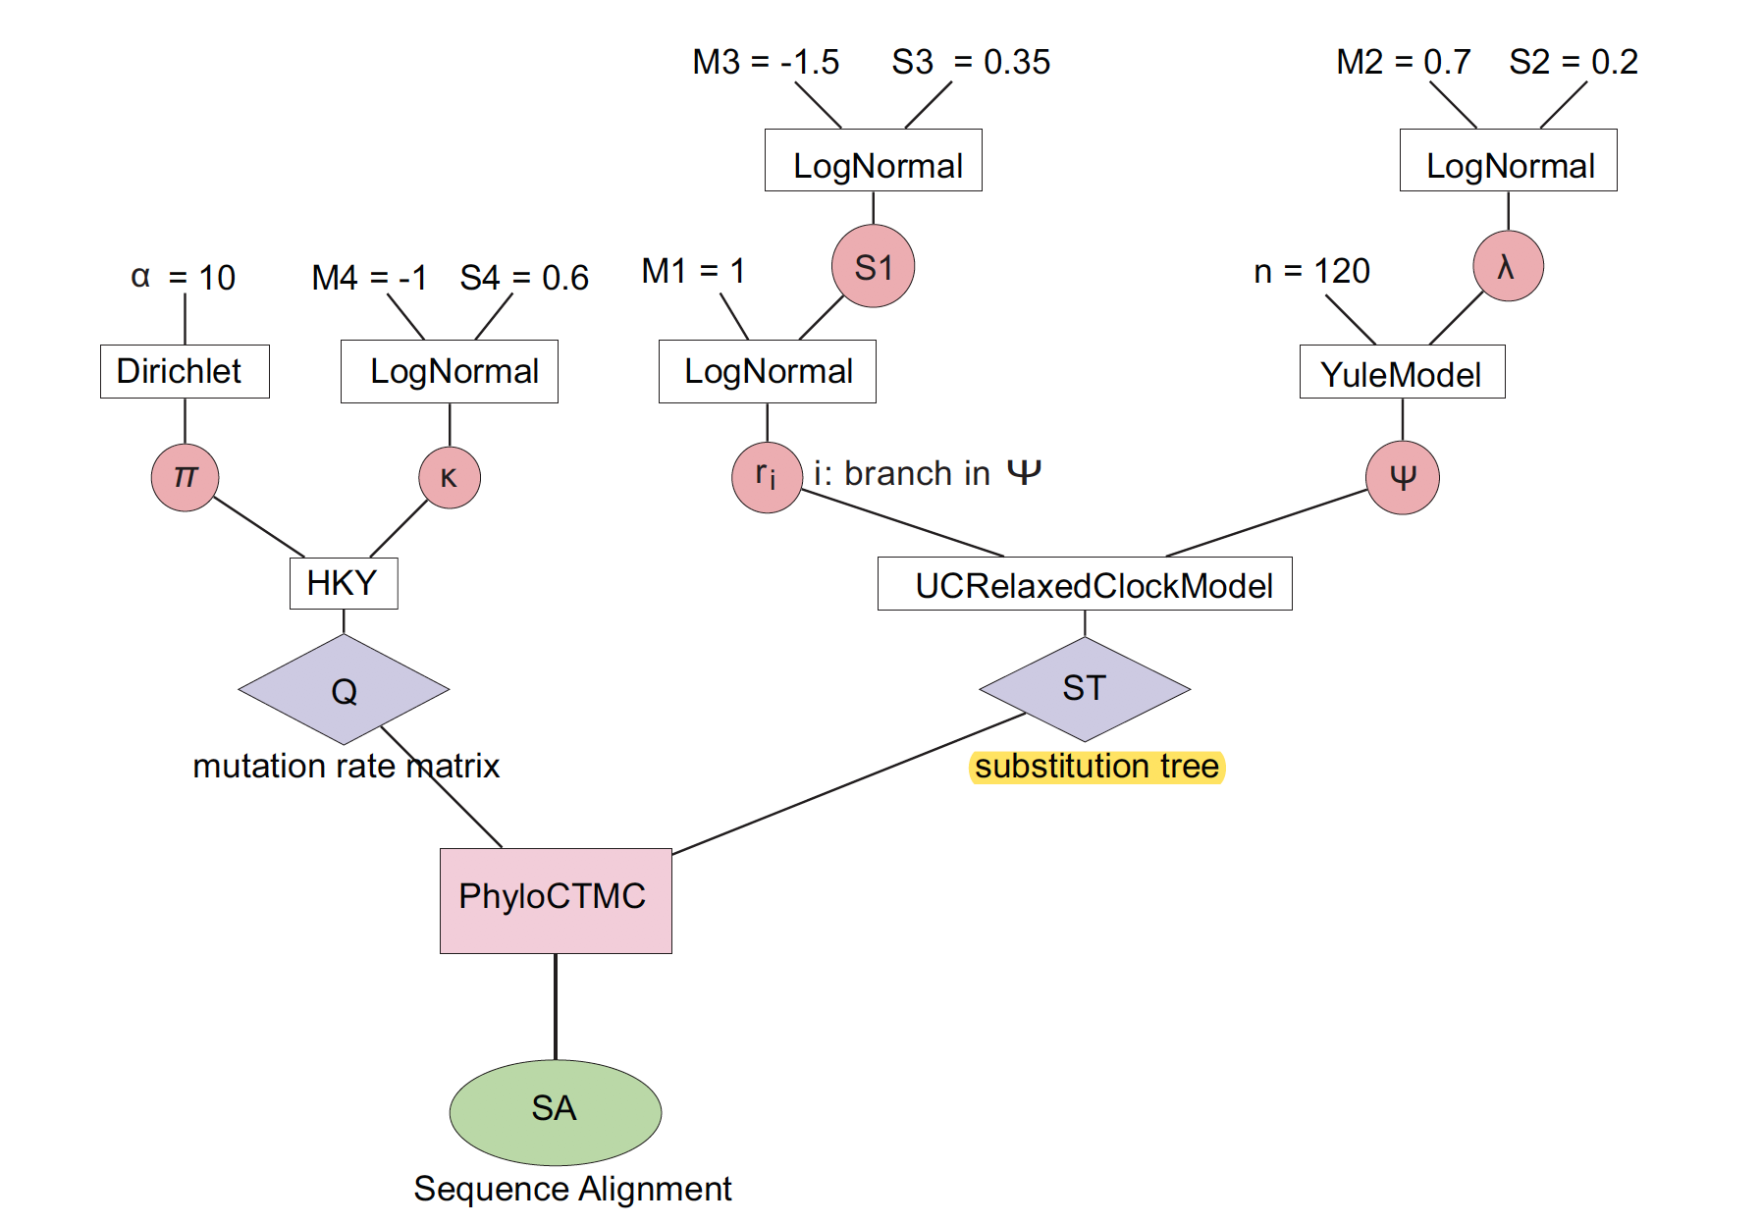

*11. Figure 16 compare -> comparison*

**We greatly appreciate the reviewer for the valuable suggestions. We try our best to overcome the deficiencies pointed out in the original submission. If there are any problems in the revised version, please do not hesitate to point out. We will revise the submission according to reviewer’s suggestions.**